This document walks you through steps for AWS educate account creation. Go to <https://aws.amazon.com> and enter your details. Make sure to enter the mizzou email address to take advantage of $100 educational credit.

Use original email address, for example: [skaf48@mail.missouri.edu](mailto:skaf48@mail.missouri.edu)

You might have customized your email addresses but amazon won’t accept any other email address. Your email domain should match institution's domain which is **mail.missouri.edu**

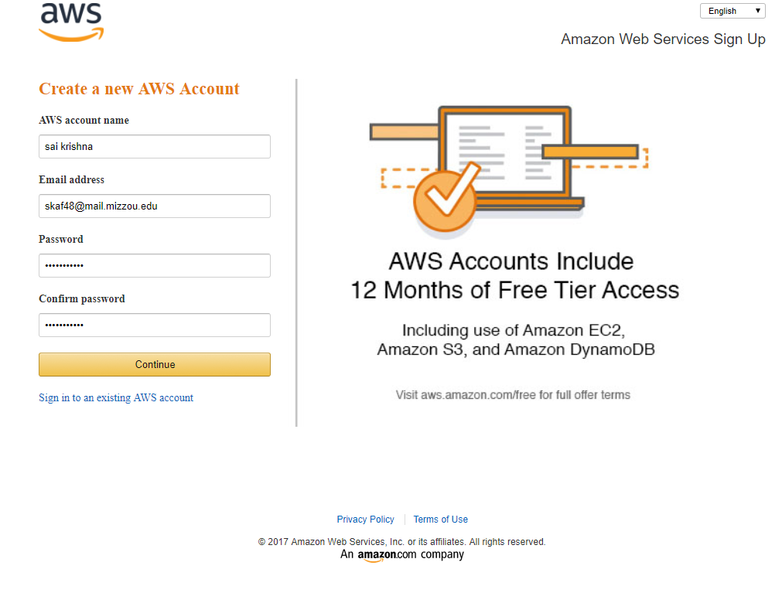

Choose personal account and enter details

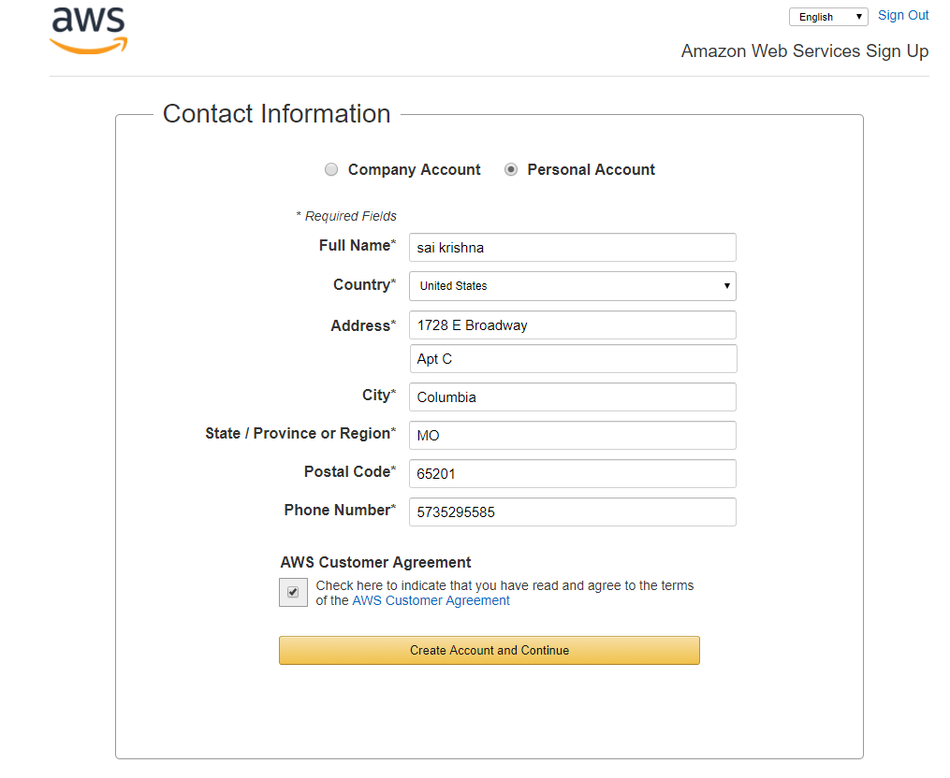

Enter your card details

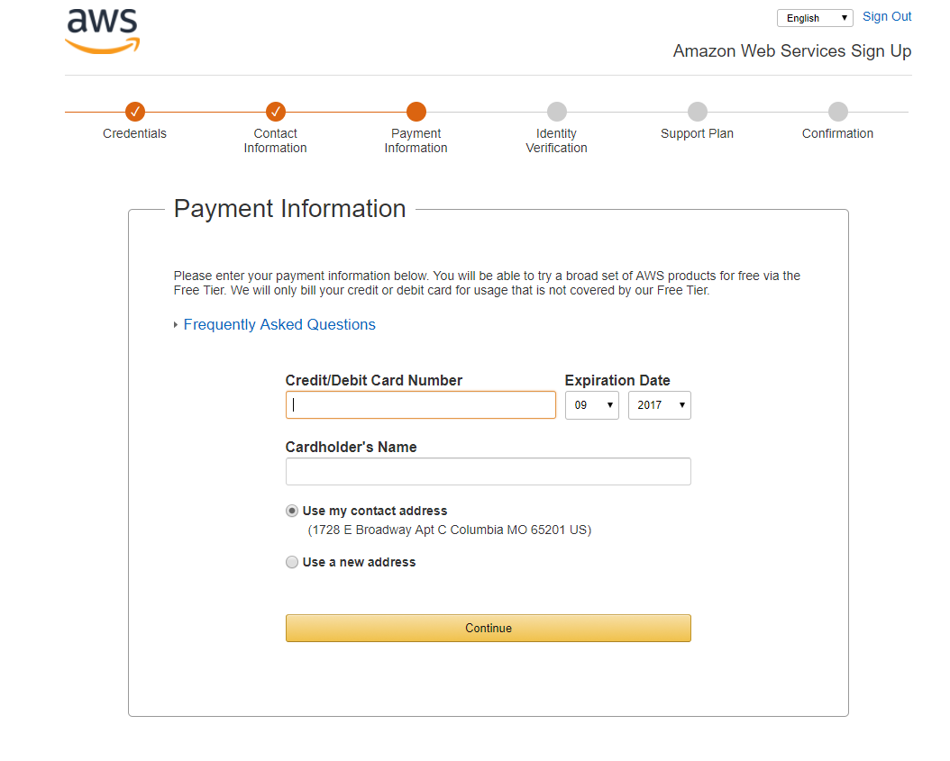

Don’t forget to select ‘Basic’ Support plan to access AWS free services

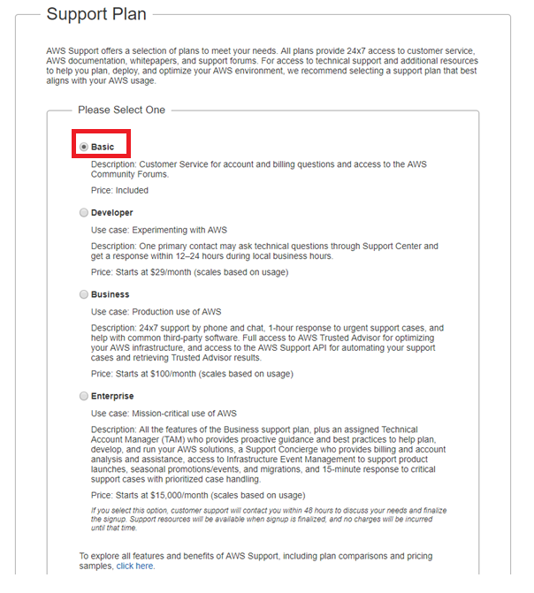

Click on your name at top right corner and go to My account. Copy the account id as we will be using next.

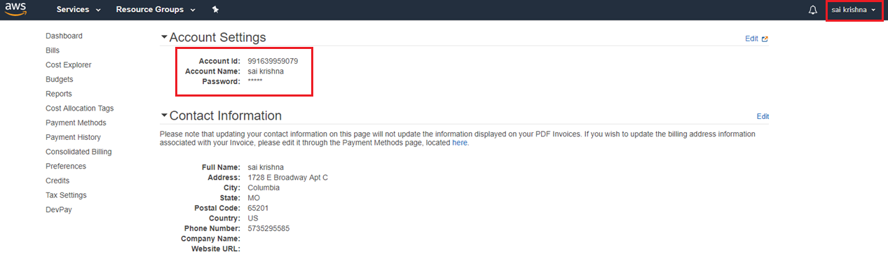

Once account is created go to below link to apply for AWS educational credit

<https://aws.amazon.com/education/awseducate/apply/>

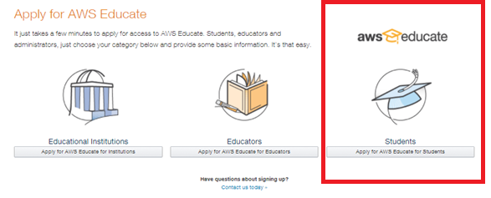

Enter details regarding school and graduation. Since we don’t have a promo code yet, we will skip. Click on next. Enter the account id you copied before.

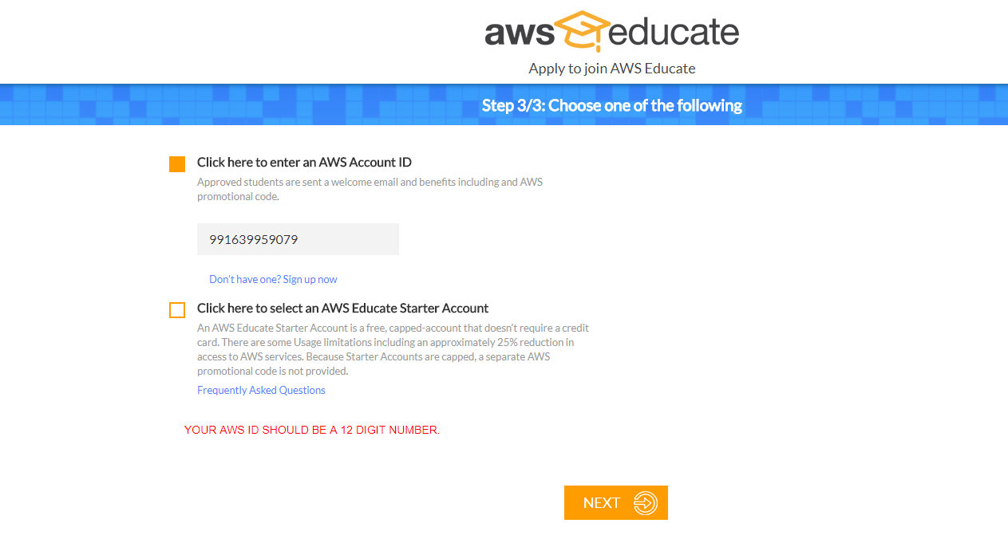

Scroll to the bottom of user agreement and accept it.

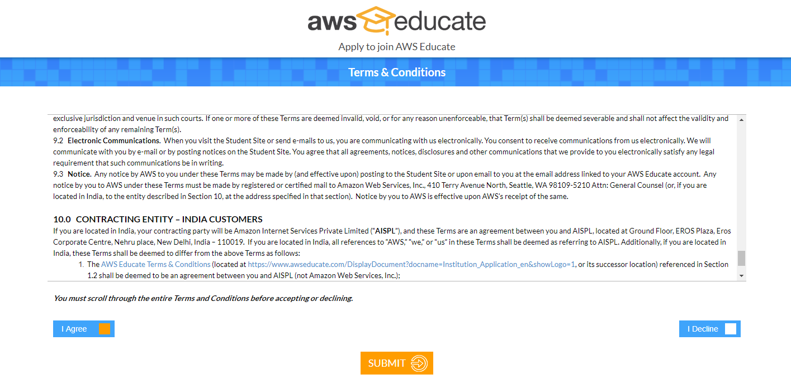

You should see confirmation message on screen.

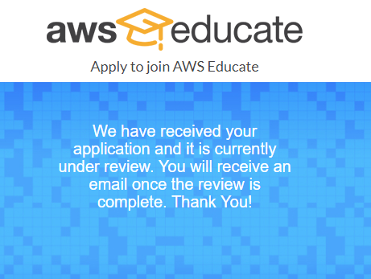

Once you received an email from AWS with the Promo Code, activate it by entering it on ‘Credits’ tab as shown below.

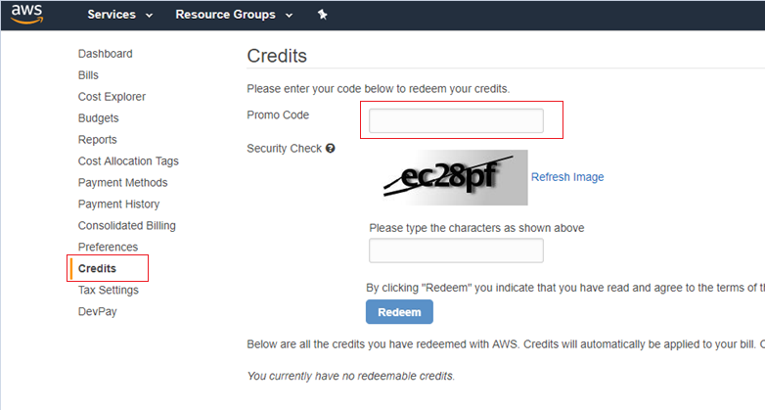

You will be able to see your detailed usage and Credits Balance by accessing ‘Bills’ option in the left menu.

Click on preferences tab on the left and enable ‘Receive PDF Invoice my Email’ as well ‘Receive Billing Alerts’ to keep track of the usage.

